Setting Up an EC2 Instance and CloudWatch Alarm

The Nautilus DevOps team has been assigned to provision an EC2 instance for their application. To ensure optimal performance, they are required to configure a CloudWatch alarm that monitors the instance's CPU utilization. The alarm must activate if CPU usage exceeds 90% during any continuous 5-minute interval. Notifications should be delivered through the pre-existing SNS topic, datacenter-sns-topic.

- Launch EC2 Instance: Create an EC2 instance named datacenter-ec2 using any appropriate Ubuntu AMI.

- Create CloudWatch Alarm: Create a CloudWatch alarm named datacenter-alarm with the following specifications:

- Statistic: Average
- Metric: CPU Utilization
- Threshold: >= 90% for 1 consecutive 5-minute period.
- Alarm Actions: Send a notification to datacenter-sns-topic

- Ec2 instance created as per requirements.

EC2 Instance Provisioning
The EC2 instance was created as specified in the requirements. This ensures that the instance is available for application deployment and further monitoring as part of the DevOps team’s mandate.

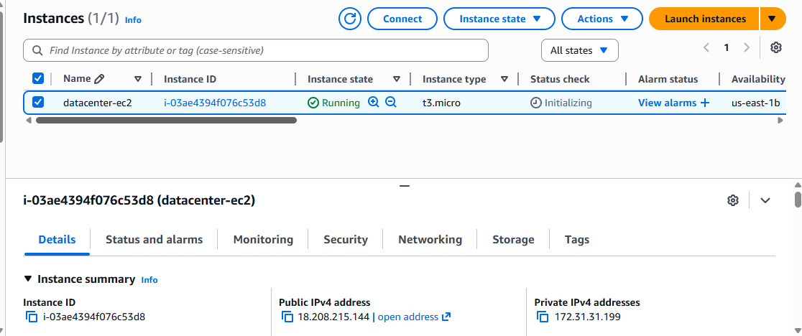

- Once instance launched then go to CloudWatch and click on create alarm

EC2 Instance Creation
The EC2 instance was successfully provisioned in accordance with the specified requirements. This ensures that the environment is ready for the deployment of the application and supports the ongoing monitoring activities assigned to the DevOps team.

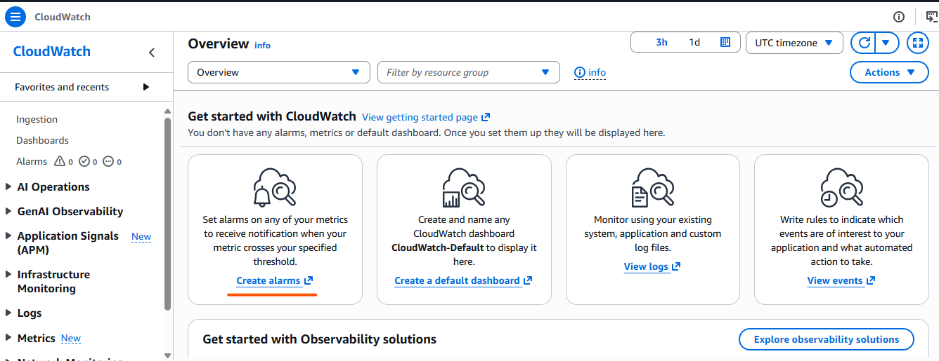

- We need to select metric
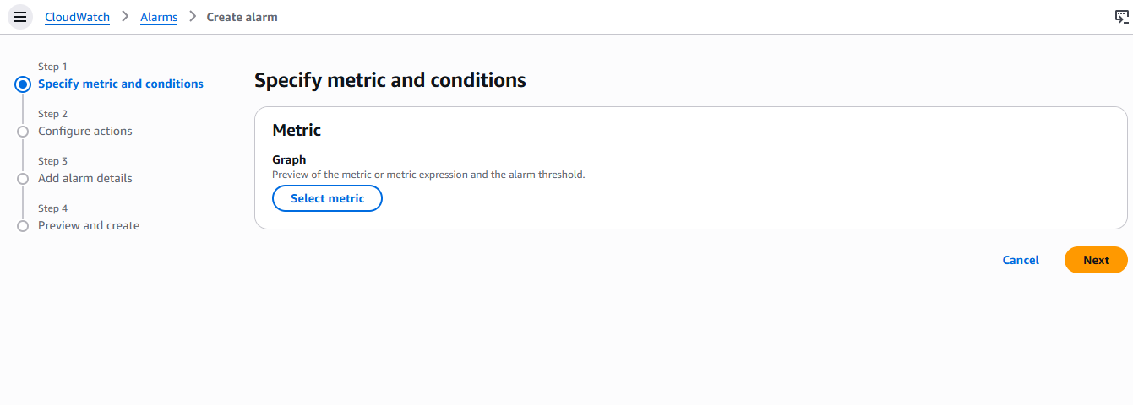
- Then we must select metric which is CPU utilization

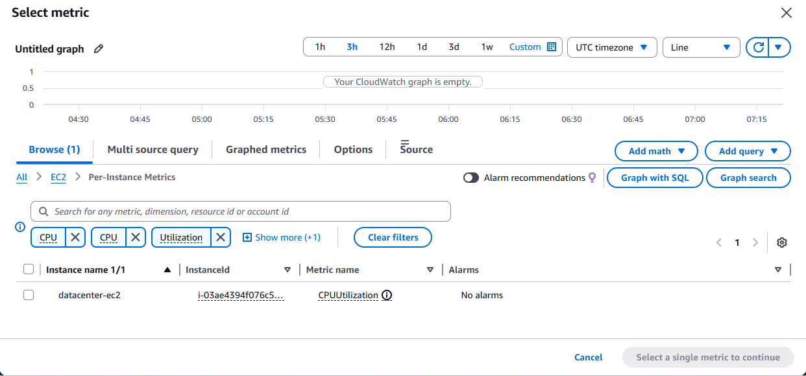
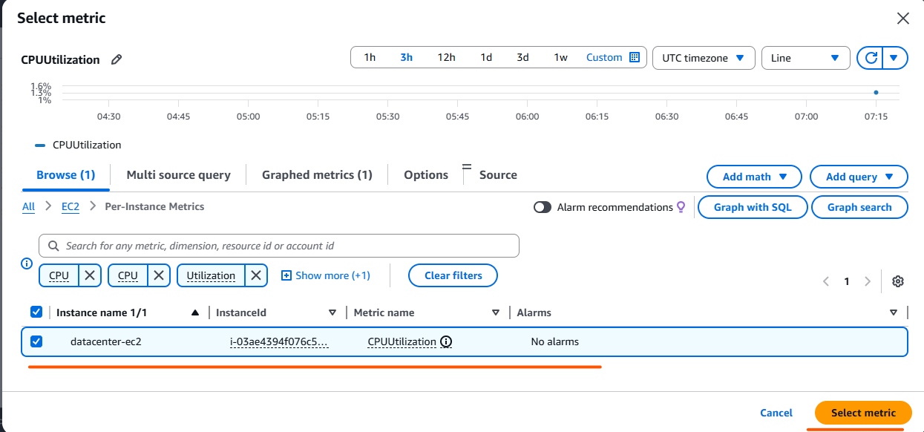

- Select condition which is provided in task

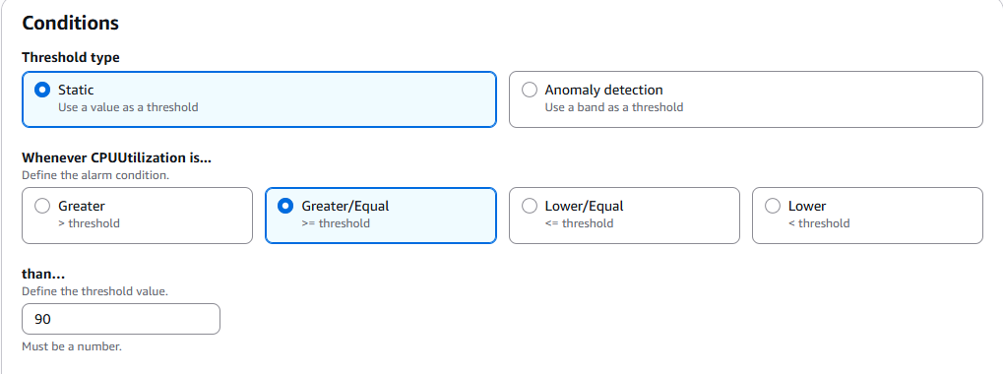

- In alarm select an existing SNS topic
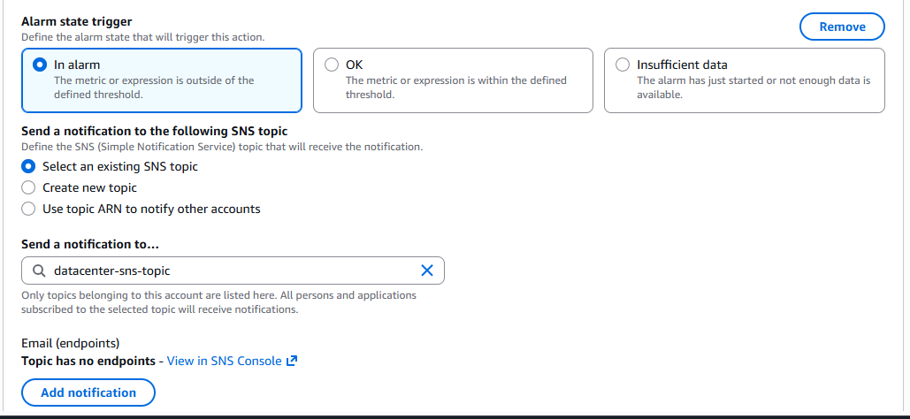
- Select alarm name
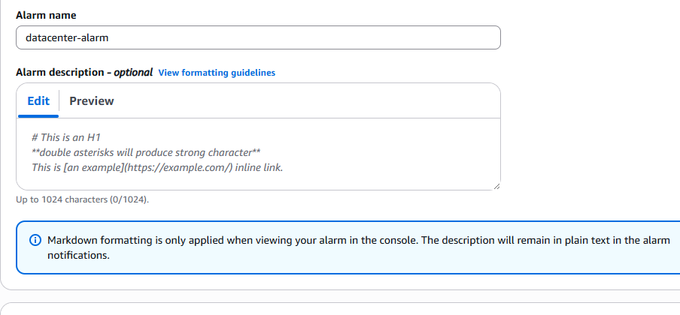
- Alarm has been created as per requirement
